CMPT 756 Kube Squad/Square Term Project Report

|  |  |  |  |  |  |
| --- | --- | --- | --- | --- | --- |
| **Team Name** | Kube Squad/Square |  |  |  |  |
| **CourSys team URL** | https://coursys.sfu.ca/2022sp-cmpt-756-g1/groups/g-kube-square |  |  |  |  |
| **GitHub project repo URL** | https://github.com/scp756-221/term-project-kube-squad/tree/music-service-port |  |  |  |  |
| **Team Member Name** | Aidan Vickars | Rishabh Kaushal | Anant Awasthy | Karthik Srinatha | Abhishek Nair |
| **Email (SFU)** | avickars@sfu.ca | rka73@sfu.ca | asa404@sfu.ca | ksa166@sfu.ca | asn4@sfu.ca |
| **Github ID** | avickars | rishabhkaushal07 | asa-404 | Karthiksrinatha | abs990 |
| **Additional Notes** | | | Currently the development branch we are using is "music-service-port". We will be changing to "main" once the project is complete. | | |

# Summary of Application

Due to the large number of members in our group, as well as general interest we developed three original micro-services that work together to form a playlist application with authentication and subscription services. The application is visualized below in Figure 1.

*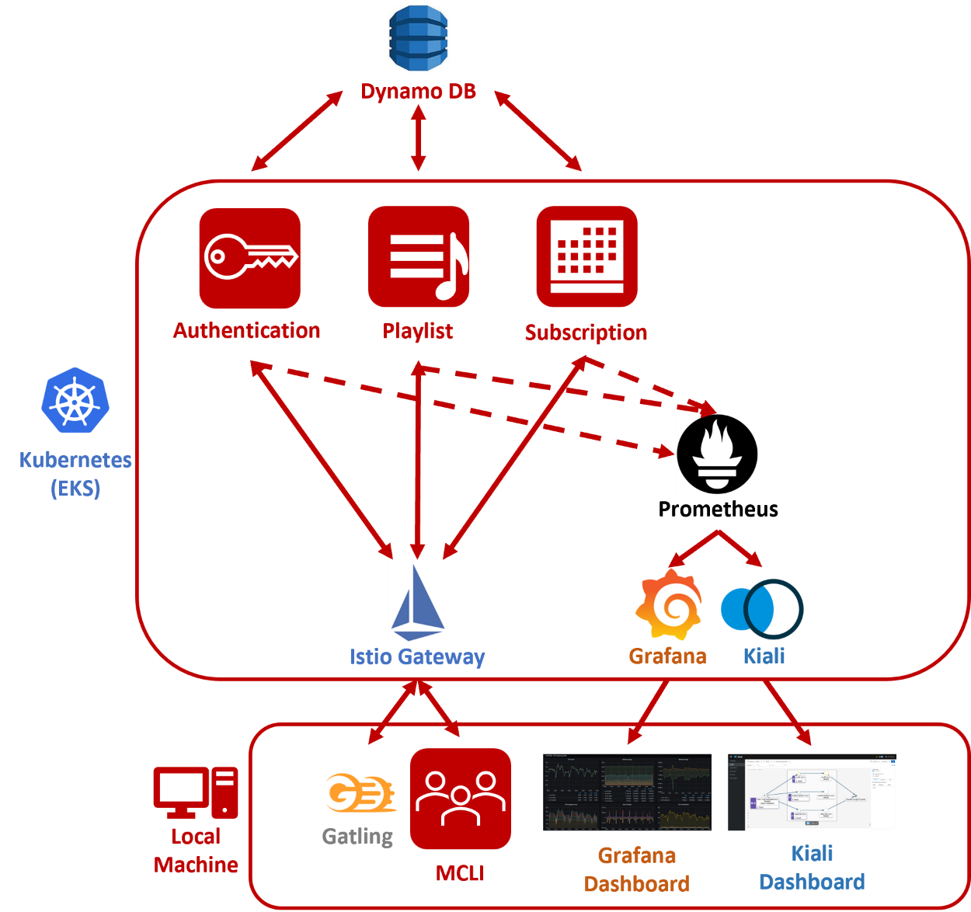Figure 1: Playlist Application*

As stated above, the application was designed to run as three containerized micro-services that run on Kubernetes. Beginning with the Authentication service, this service allows users to create or login into their account respectively and subsequently access the Playlist service that will be described shortly. Like any normal application, accessing features often requires a paid subscription. Our application is no different; accessing the features in the Playlist service requires a paid subscription. We have implemented this in the Subscription service, where after logging in or registering for an account users can choose their preferred subscription option and subscribe by adding a credit card that passes through a simulated validation. Once users have logged in and subscribed, they can access the Playlist service that contains a variety of features. These features include creating, viewing, and editing playlists, as well as finding information related to specific songs such as the lyrics, genre, and artist. All three services use Dynamo DB for storage and independently query the database to access information like user accounts, song information, subscription status etc.

From the client side, to make requests to each service we used two tools. The first is a modified version of the given MCLI application that has been fitted to make the appropriate http requests to our microservice. The second is Gatling where we have created test suites to place varying amounts of load on each service. To assess how well the application responds to load, we have configured Prometheus, Grafana and Kiali to gather and visualize metrics accordingly. This will be discussed further in our analysis below. Finally, to distribute the load for each service we have created a gateway into the cluster using Istio that acts as the load balancer for the entire system.

# GitHub Guide

Beginning with the structure of the GitHub repository, the central branch is “music-service-port” that contains the most recent working build of the application. It is expected that any team member that merges their work into this branch, verifies that the branch remains in an error free condition. It should be noted that once the application is completed, the “music-service-port” branch will be merged into the “main” branch. Furthermore, we utilize branching extensively during the development process. When a team member is actively working on a feature or bug, they create a new branch to use as their working copy and merge their work into the “music-service-port” branch when ready. This is reflected in the large number of branches that the repository contains that at the time of writing is 15.

To augment our development, we make extensive use of GitHub’s projects and log every item of work as an issue in the ”756 Project” that contains our active kanban board. In this board, there are four separate columns that contain the backlog, to do, in progress and done items. In our typical workflow, team members will freely add issues to the backlog that likely need to be completed later. In our weekly scrum backlog items are moved into the to do column when as a team we feel they need to be completed in the coming sprint and are subsequently assigned to a team member. At the same time, other backlog items are often removed from the board entirely when the team decides they are obsolete.

Whenever a user embarks on a new piece of work, they move the corresponding issue into the “in progress” column or if the issue has not already been created, they create the issue first before continuing. Finally, once the issue is completed it is moved to the “done” column. At the time of writing there are 77 issues in the “done” column. It should be noted, we do attempt to link our commits to the relevant issues, however we have found that remembering to do this is rather difficult.

# Observations

## Reflection on Development

**What did you observe from applying and using the scrum methodology? What worked well? What didn’t? What surprised you?**

After applying and using scrum methodology, we made three significant observations. The first is that it allowed us to assess more accurately our currently velocity towards completing the project. Due to the nature of course work that often comes in waves, team members development capacity often significantly fluctuated week to week. By having weekly scrums, we were able to properly define what the definition of done for the upcoming sprint such that it was achievable. Furthermore, in the case a team members capacity changed on short notice (ex: assignment was pushed back), having weekly sprints allowed us to pivot quickly.

The second observation we made was that the consistent cadence that scrum often requires did not work. As mentioned above, team members development capacity would significantly fluctuate week to week. As a result, there were sprints where the entire team’s development capacity was effectively zero and the resulting sprint goal was nothing. Thus, the team was unable to maintain a consistent cadence that at times defeated the purpose of scrum because there was simply no point in having one since no one had capacity to perform any work.

The third and final observation we made was that it normalized the behaviour of demonstrating one’s work to the team. By applying scrum, it normalized the expectation of demonstrating the completed items from the last sprint. We found this to be particularly useful because it served as both an opportunity for everyone to demonstrate their work, but also as an opportunity to teach others how to utilize their completed work. An example of this was the containerization of the application where each service was ported to work as containers. After demonstrating the applications running as containers, each team member became familiar with the process of building and running the application.

**Reflect on the readings over the course of the term. What ideas were you able to apply? How did these turn out?**

Beginning with the second reading that featured a comparison between mono and poly repositories, we applied a mono-repository to great success. Due to the size of the application, using a poly-repository would have created additional overhead in managing the location of each micro-service. In contrast, by using a mono-repository we were able to easily create a single source of truth that contained the application that facilitated rapid deployment and iteration. This, rapid deployment was further enhanced by the “infrastructure as code” ideas that were also presented in the second reading. To implement this, we wrote a comprehensive make-file that contains every command required to deploy the application in both a local and cloud format. This enabled a consistent deployment practice that eliminated all confusion around the deployment of the application. It should be noted that our use of containers and make files to facilitate the deployment of the application captured ideas from the third reading as well that discussed containerization and make-files.

TO BE DISCUSSED – KUBENETES IMPLEMENTATION – READING 4 – While the application has been configured to run on Kubernetes, we are waiting to test the application under load before discussing this. This section will be completed in the final report.

Moving on to the seventh reading that discussed micro-services, we found implementing our application as three micro-services enabled rapid parallel development. Because of the isolated nature of each service, we were able to rapidly complete all of them in the span of approximately two weeks with minimal integration issues and in a continuous fashion as described in reading 8. By having each developer merge their work into the “music-service-port” branch, we were able to continually develop the application while maintaining a working and stable version.

**If you have professional experience with scrum, how did your team perform in comparison to past teams?**

Our team performed both well and poorly compared to our professional experiences with scrum. From a cadence perspective our team performed quite poorly. As discussed previously we were unable to maintain a consistent cadence that contrasts with our professional experiences. In our previous professional environments, our focus would often be on a single project and as a result we were able maintain a consistent cadence towards completing items in each sprint. On a positive note, during times when our team was actively developing, utilizing scrum enabled us to ensure there was no duplication of work. This is in stark contrast to some of our professional experiences where we would often perform a significant amount of work only to find later that there was existing work that could have easily been utilized instead. An example, of this is writing large portions of code only to find out that there was existing code base that could have been easily ported over to the current project.

## Reflection on Operating the Application

We are currently configuring Gatling to apply load to our application. This is expected to be completed within this current sprint (by March 21). As a result, we cannot write this portion of the report yet. This will be completed in the final report.

# Analysis

To assess how our application scaled while under varying load from Gatling, we leveraged Prometheus, Grafana and Kiali. Prometheus was used to gather various metrics, while Grafana and Kiali were used to produce visualisations of the services. To be succinct, we used Grafana to gain a greater understanding of the latency in the services, and Kiali to understand how requests were passing through the system. We also used the reports from Gatling after each load test to assess the failure rates of the requests.

## Request Flow Analysis

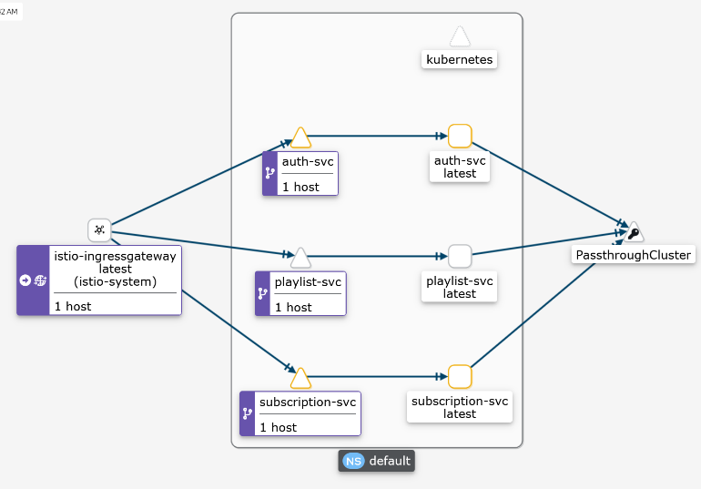 Beginning with the visualization produced by Kiali that shown in Figure 2, we can see how traffic flows through our application. Initially, all traffic flows into the gateway we defined using Istio that then distributes the load to each service accordingly. The reader will note that for each service there appears to be two pods or services. This is just a visualization of the routing configuration that have been defined for each service. The reader can interpret the multiple services for each service as one. Once a request has reached a service, the service then makes corresponding requests to another service outside the cluster. These are simply requests made to Dynamo DB. However, since it exists outside the cluster it is not managed.

Figure 1: Application Request Flow

## Scaling Analysis

Now that it is understood how requests flow through the application, we assessed the scaling of the application under varying loads. To do this we defined two tests that have been applied to each service. These tests are defined below.

***Test A:***

*Number of Users: 1000*

*Flow:*

*For every endpoint in the service:*

* *Make requests*
* *Pause for 3 seconds*

***Test B:***

*Number of Users: 10 000*

*Flow:*

*For every endpoint in the service:*

* *Make requests*
* *Pause for 3 seconds*

To assess how the application scaled, we applied tests A and B multiple times and recorded the results. The results and their corresponding explanation of every test are presented in the sub sections below. The learnings from previous tests are carried over to subsequent tests.

### Test 1

**Configuration:**

* Target Service: Authentication
* Replication Factor: (1 - Authentication, 1 - Subscription, 1 - Playlist)
* Number of Nodes: 2
* Test: A

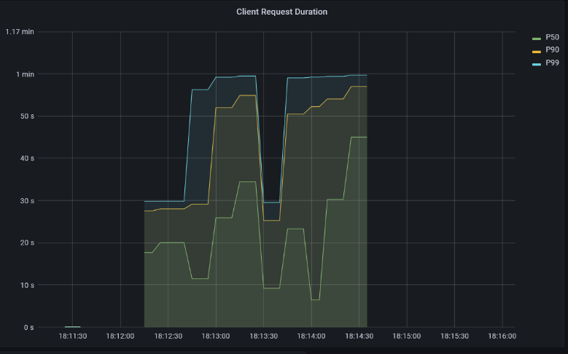

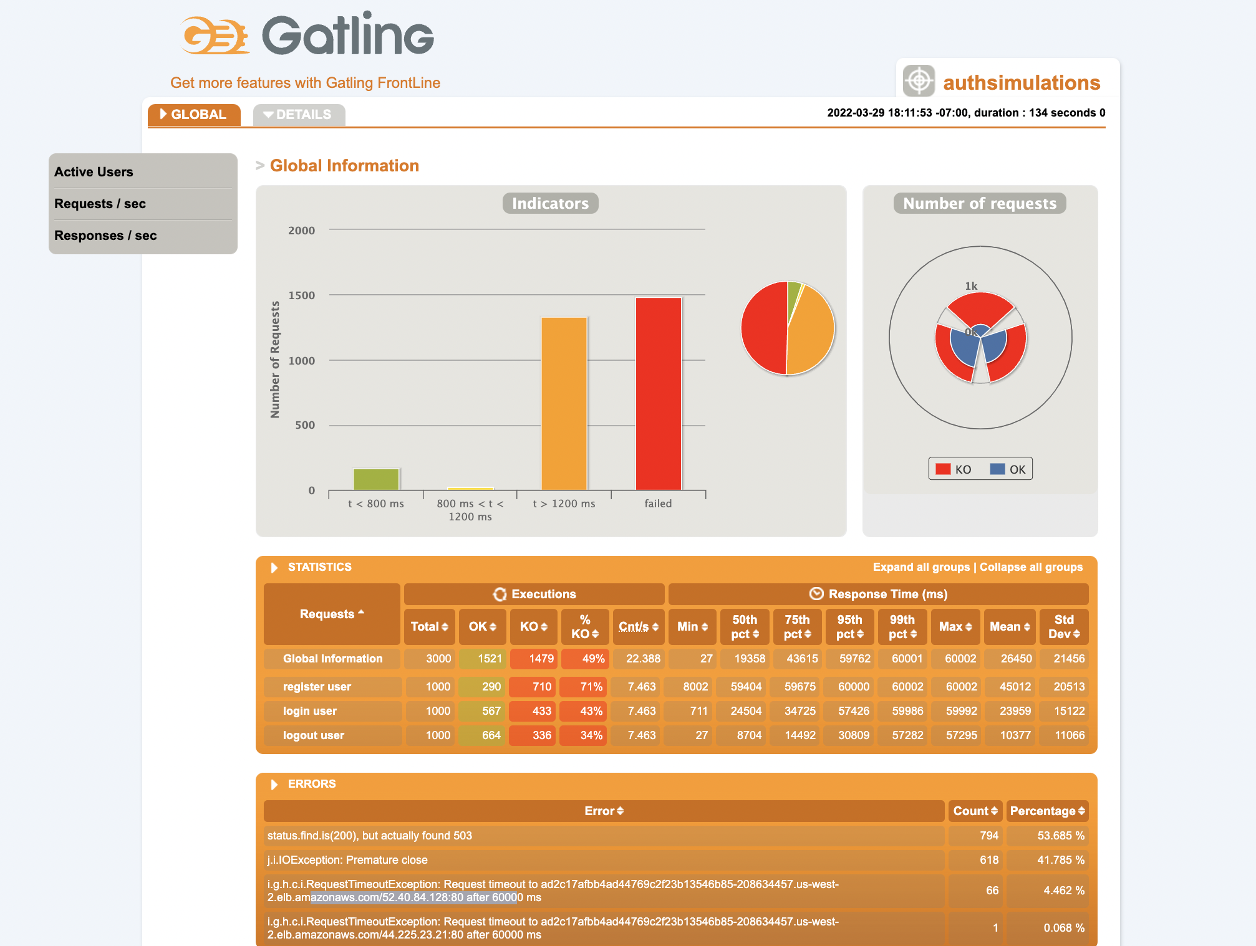**Results:**

Gatling Report

Latency (Grafana)

**Learnings:**

From the report produced by Gatling we can see that there was a very large number of failed requests. We found that most of these failures were due to timeout errors. This corresponds with the latency vitalization we’re even the 50th percentile was almost 50 seconds. These results clearly indicate that the current configuration is insufficient. To remedy this we tuned the application by varying the replication factor of the authentication service from 2 - 8. The results of the test with a replication of 8 applied to the authentication service is shown in test 2.

### Test 2

**Configuration:**

* Target Service: Authentication
* Replication Factor: (8 - Authentication, 1 - Subscription, 1 - Playlist)
* Number of Nodes: 2
* Test: A

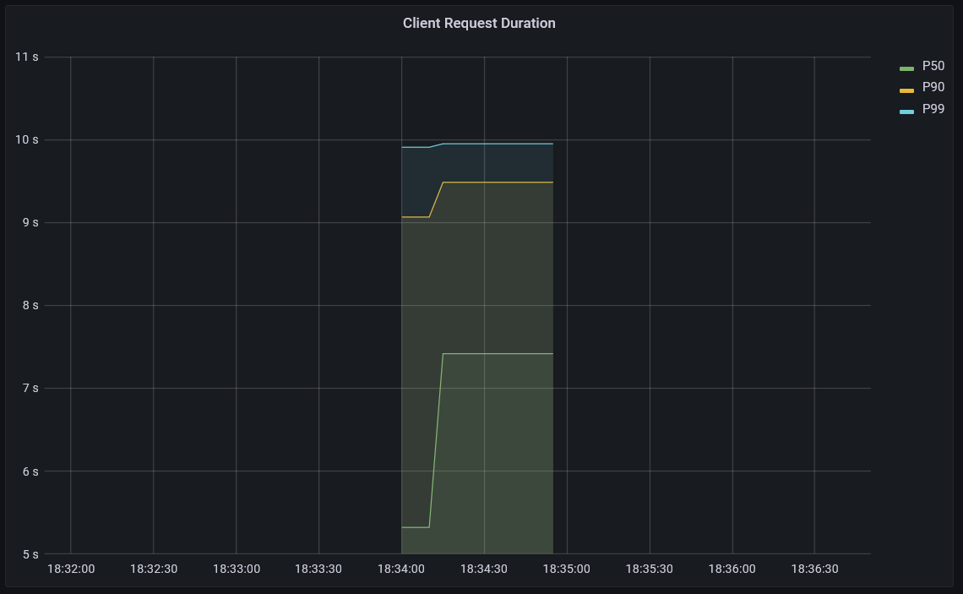

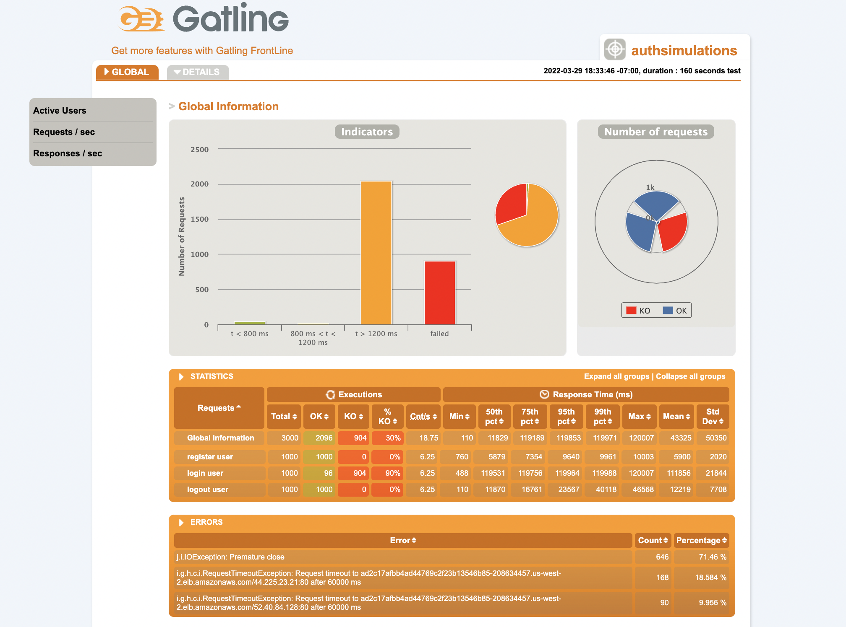**Results:**

Latency (Grafana)

Gatling Report

**Learnings:**

After tuning the replication factor to 8 for the authentication service, we saw a significant decrease in the number of request failures. This is reflected in the visualization of the latency where the 50th percentile is approximately 7.5 seconds. However, we wanted to eliminate all failures. Since after increasing the replication factor significantly the application was still experiencing failures, we took this as an indication that the nodes in the cluster may be saturated. To remedy this, we increased the number of nodes in the cluster by one.

### Test 3

**Configuration:**

* Target Service: Authentication
* Replication Factor: (8 - Authentication, 1 - Subscription, 1 - Playlist)
* Number of Nodes: 3
* Test: A

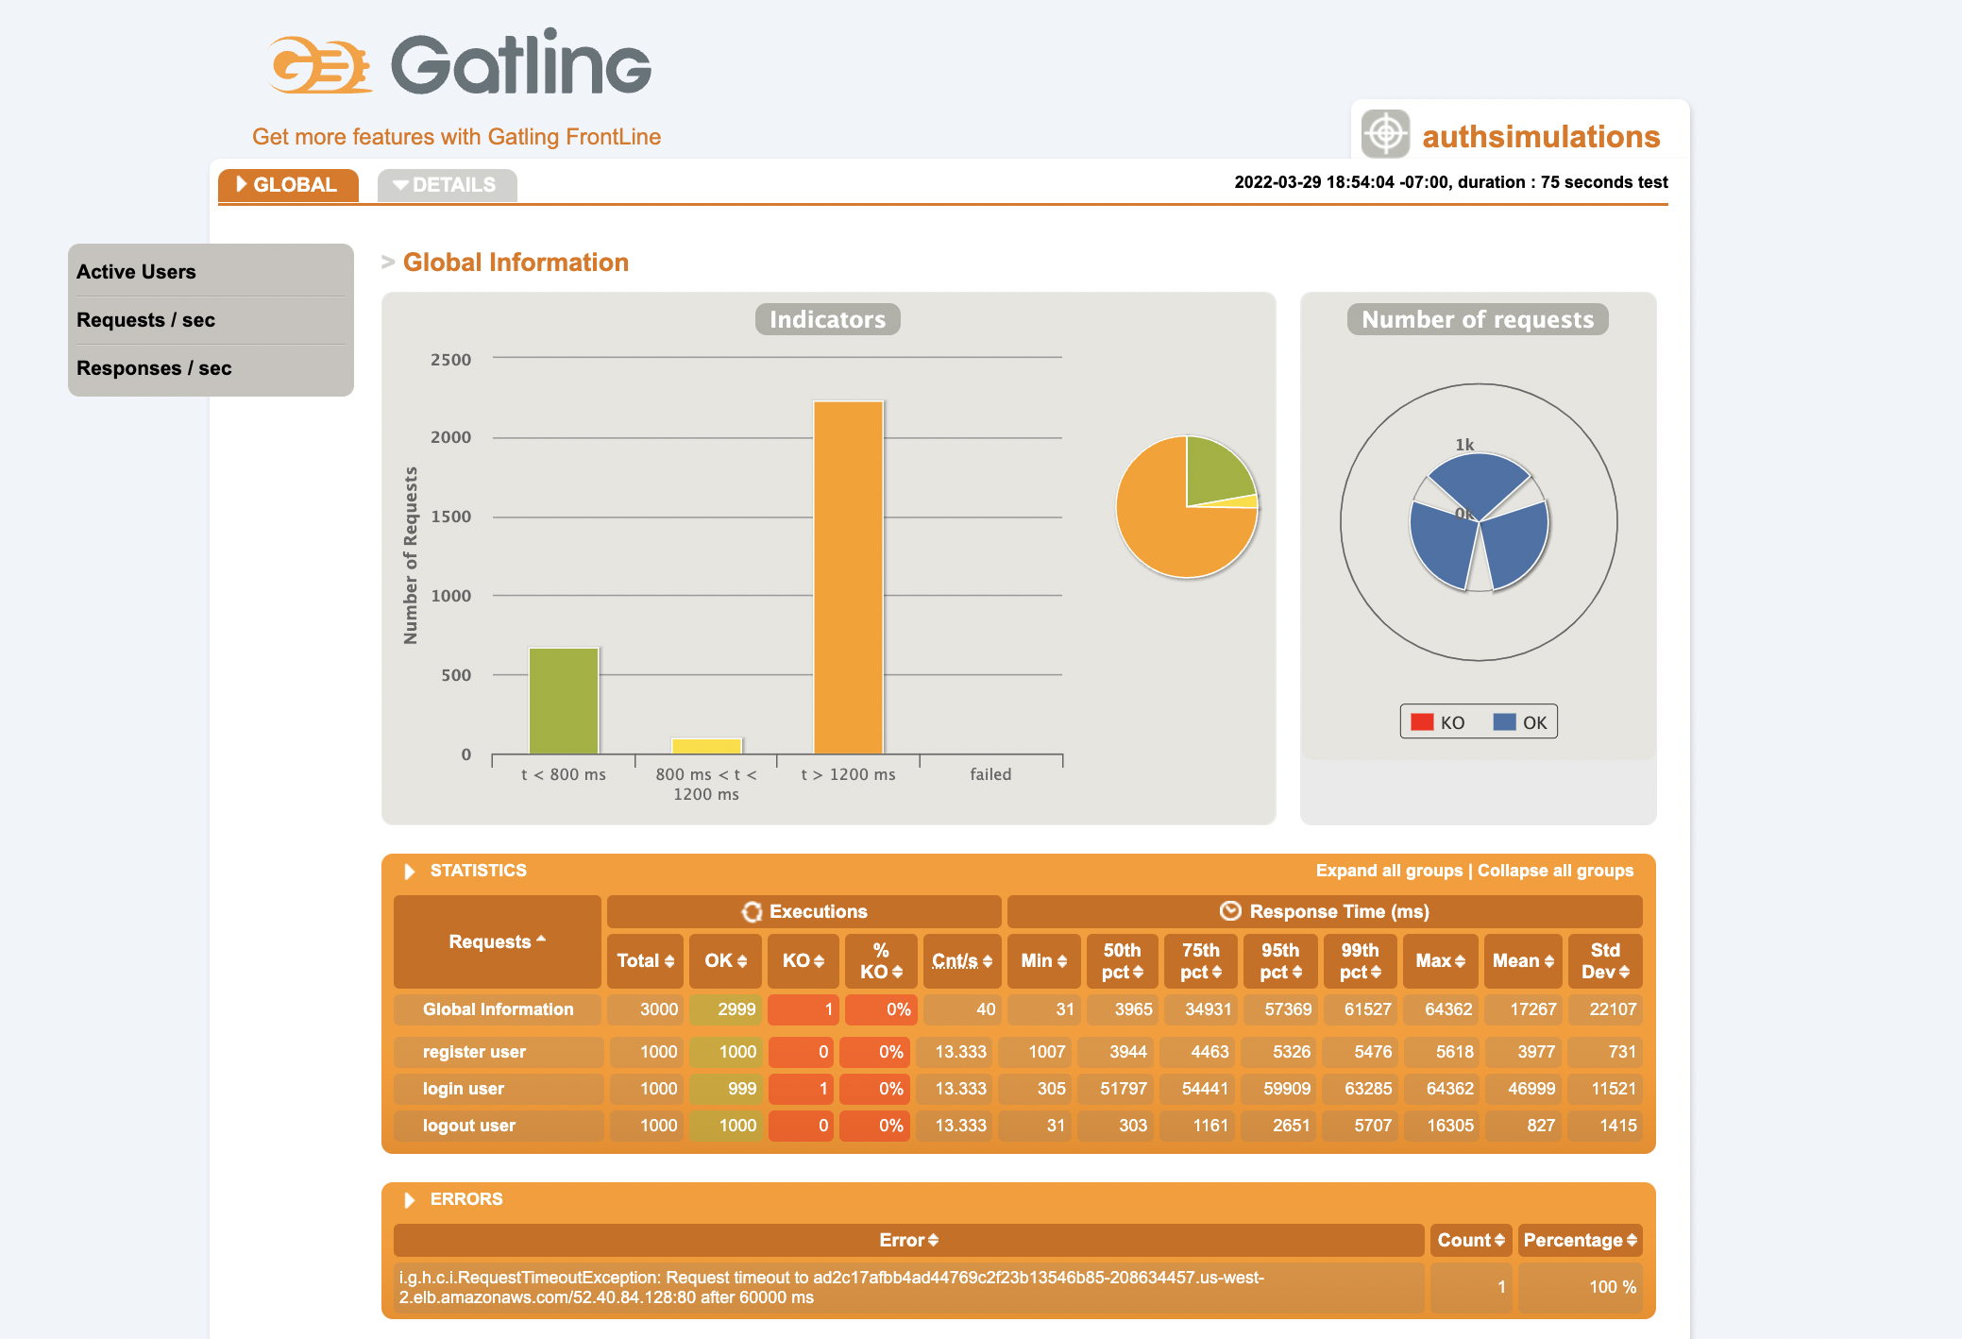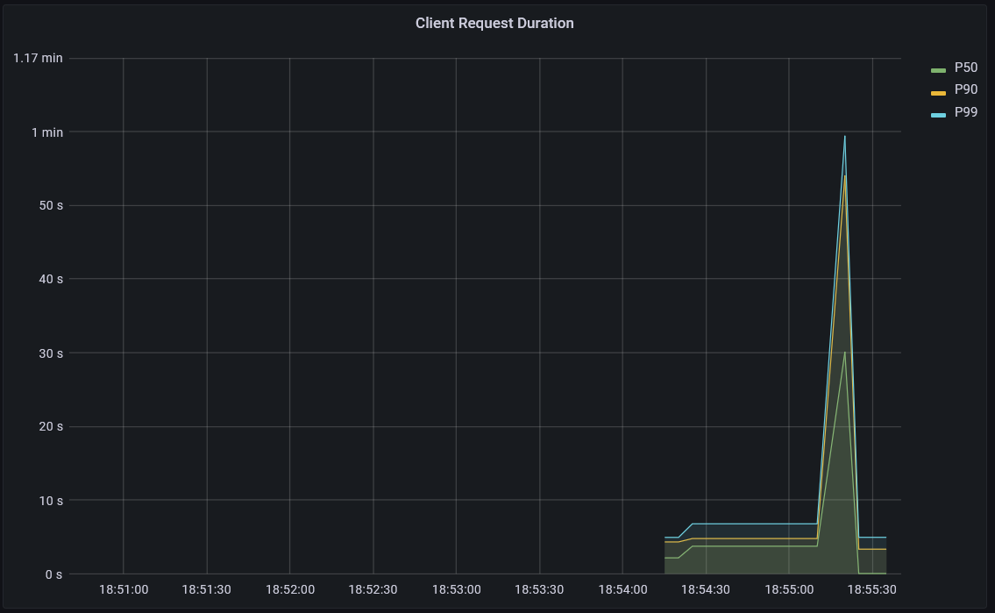**Results:**

Gatling Report

Latency (Grafana)

**Learnings:**

We found that once we increased the number of nodes, we were able to eliminate all failures. Furthermore, we can see a significantly improved latency in both images. In the Gatling report, there are significantly more responses with a latency under 800 milli-seconds. This is reflected in the Grafana visualization where even the 99th percentile is under 10 seconds aside from the single large spike. Now, that the application has no failures and lower latency, we apply test B below.

### Test 4

**Configuration:**

* Target Service: Authentication
* Replication Factor: (8 - Authentication, 1 - Subscription, 1 - Playlist)
* Number of Nodes: 3
* Test: B

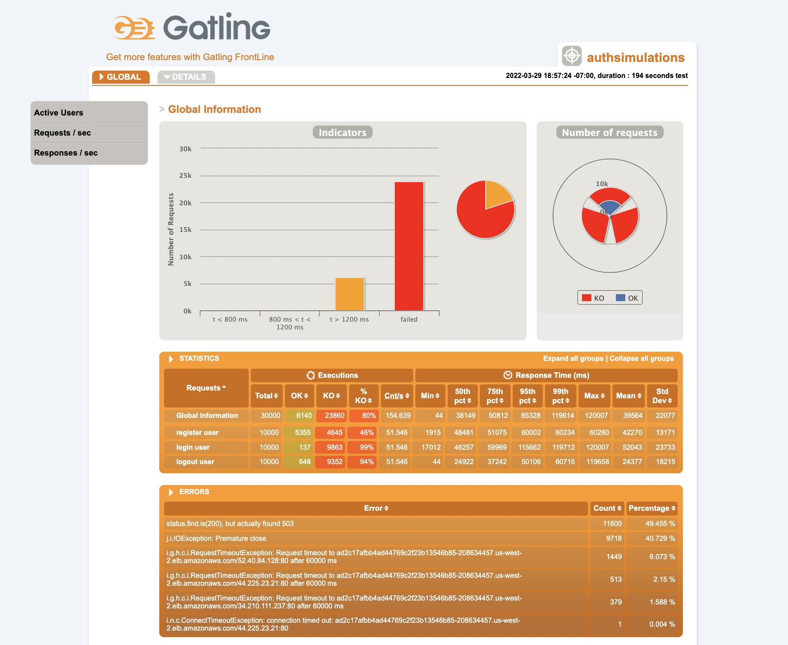**Results:**

Gatling Report

**Learnings:**

In test 5 the number of concurrent users and requests per second increases by factor of 10. In the Gatling report the results are clear in the huge increase in failures. The failures were so numerous that Grafana would not actually produce the latency visualization and as a result is not shown. This clearly shows that the current configuration of the cluster is insufficient in both the replication factor and the number nodes. To remedy this, we did increase the number of nodes to 4 and re-executed the test. We also increased the replication factor as well over varying sizes. However, in either case we saw no improvement. Due to the 10x increased load in test B relative to test A, we theorize that to achieve significantly better results we would need to increase the configuration of the cluster by a factor of ten as well in both the replication factor and number of nodes. Furthermore, we may also need to scale up Dynamo DB as well. However, due to cost limitations we do not attempt this.

### Test 5

**Configuration:**

* Target Service: Subscription
* Replication Factor: (1 - Authentication, 8 - Subscription, 1 - Playlist)
* Number of Nodes: 3
* Test: A

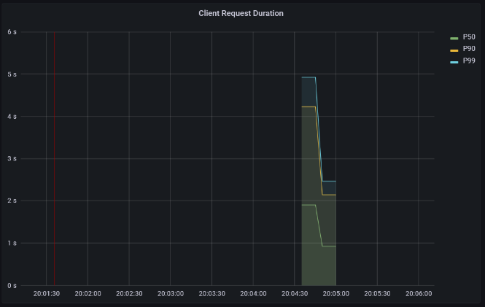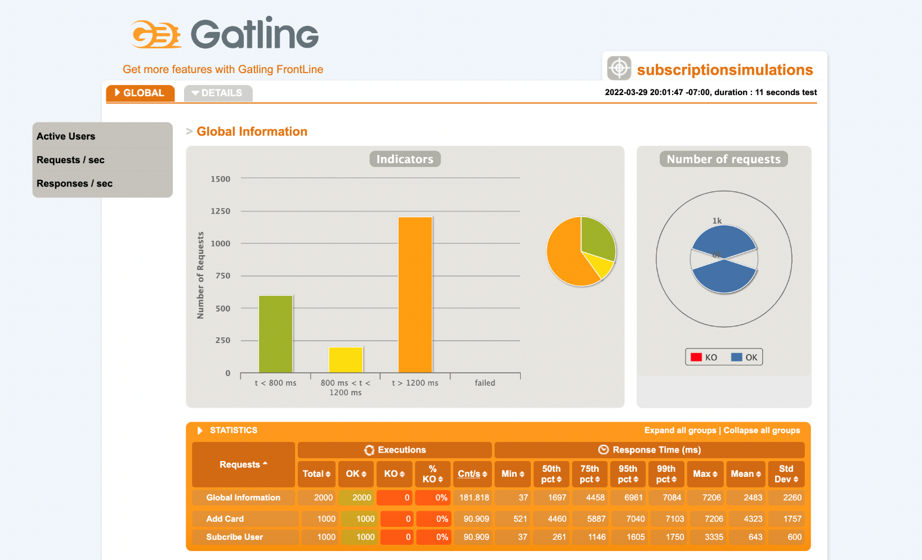 **Results:**

Gatling Report

Latency (Grafana)

**Learnings:**

Using this configuration, we achieved extremely similar results to what was achieved using a similar configuration targeting the authentication service. This configuration handles this level of load well. However, we do note that our latency is still well above 1 second. We found that we were not able to improve this in any meaningful fashion. It is possible that the latency may be coming from Dynamo DB since in both the authentication and subscription services, they are immediately querying Dynamo DB with minimal compute tasks. To be succinct, the requests to each service are essentially passing through straight to Dynamo DB.

Furthermore, in the interest of minimizing repetition this configuration was applied on the playlist service. The results were almost identical with the notable difference in that the latency was significantly higher. This was unsurprising because the requests made to the playlist service required additional filtering in Dynamo DB or outright required the entire list of songs contained in the database.

### Test 6

**Configuration:**

* Target Service: Subscription
* Replication Factor: (1 - Authentication, 8 - Subscription, 1 - Playlist)
* Number of Nodes: 3
* Test: B

**Results:**

Gatling Report

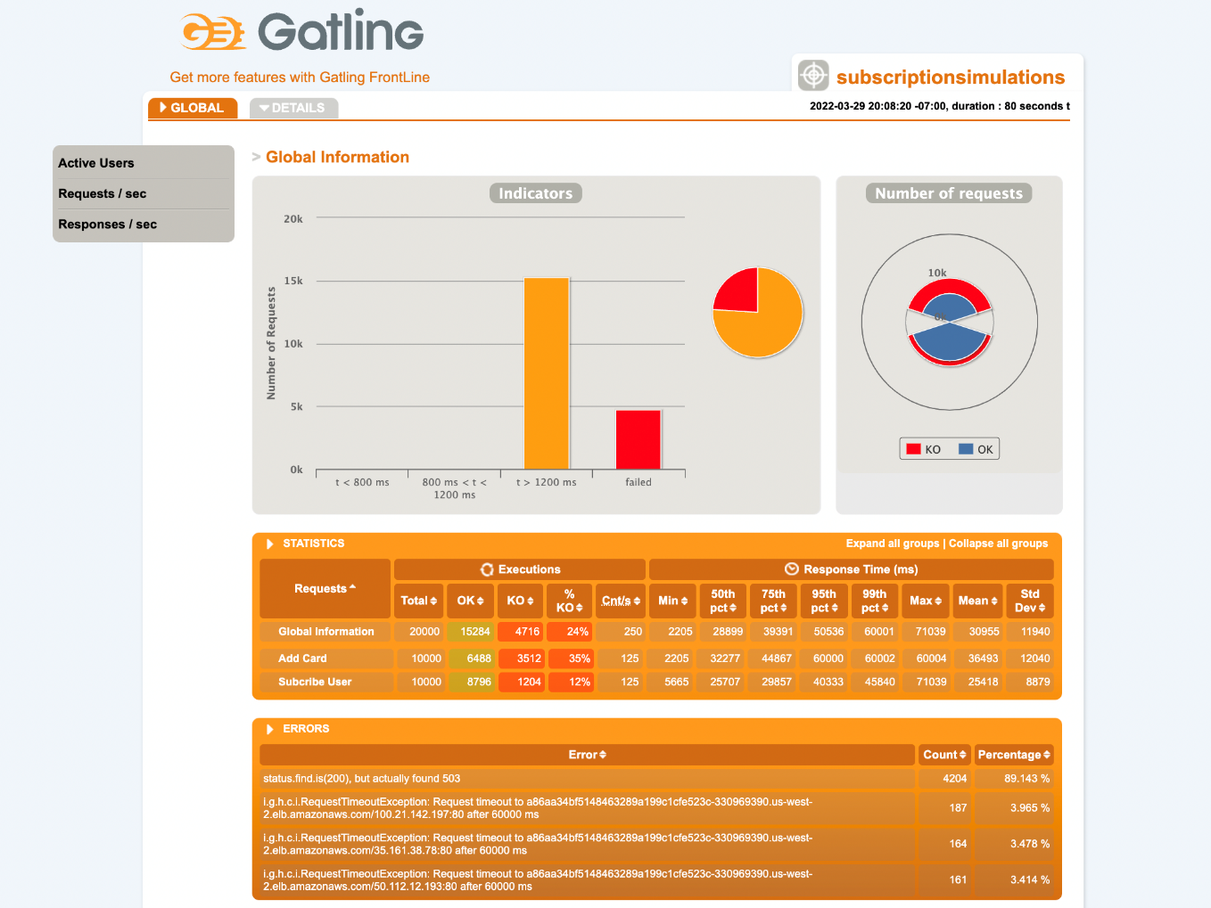

**Learnings:**

Again, in an almost identical fashion to test 4 after applying test B on the subscription service we found significantly more failed requests. Furthermore, the failures were again so numerous that Grafana would not actually produce the latency visualization and as a result it is not shown. To minimize repetition, this test was similar applied to the Playlist service with extremely similar results. Thus, we conclude again that the current cluster configuration is insufficient. To adequately handle this level of load, the cluster would certainly require additional scaling of the nodes, replication factor and likely in Dynamo DB as well.

### Test 7

**Configuration:**

* Target Service: Authentication – *with autoscaling*
* Replication Factor: Initially (1 - Authentication, 1 - Subscription, 1 - Playlist)
* Number of Nodes: 3
* Test: A

**Results:**

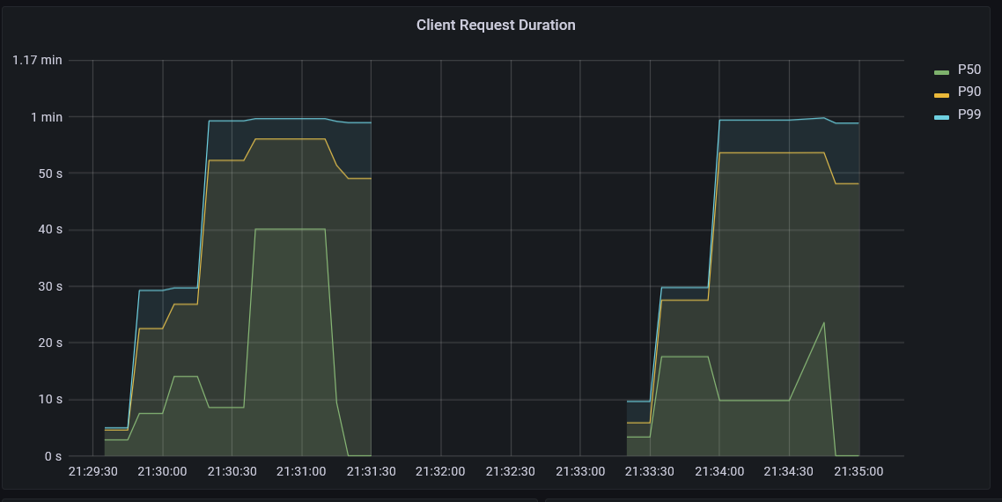

Latency (Grafana)

**Learnings:**

To incorporate what we have learned in the previous tests, we configured horizontal autoscaling in the cluster for each service according to the number of requests per second. Using a very low target of 1 request per to encourage fast scaling, we executed test A on the authentication service. We found that while autoscaling does work it takes a significant amount of time for Kubernetes to recognize that it should increase the replication factor of the pods. This can be seen in the latency visualization above where after executing test A on the authentication service two times, the latency does not improve. This is because Kubernetes required a lengthy and sustained load to recognize that it should scale the service. To be succinct, it took two executions of test A for the service to auto-scale the authentication service from 1 to 8 replicas. Once, the replication factor increased to 8, we achieved similar results to that from test 3. In short, we found that the autoscaling performs very well for clusters that experience varying but sustained levels of load. But it will not perform well on clusters that experience short and intense bursts of load. This is because Kubernetes requires time to recognize and scale the cluster accordingly that is sufficient for varying and sustained levels of load but insufficient for short intense bursts.

## Failure Analysis

To assess what happens to the application when it experiences failures, we applied tests A multiple and applied two types of failures concurrently and recorded the results.

### Test 8

**Configuration:**

* Target Service: Authentication
* Replication Factor: (8 - Authentication, 1 - Subscription, 1 - Playlist)
* Number of Nodes: 3
* Test: A
* Failure: Pod Failure

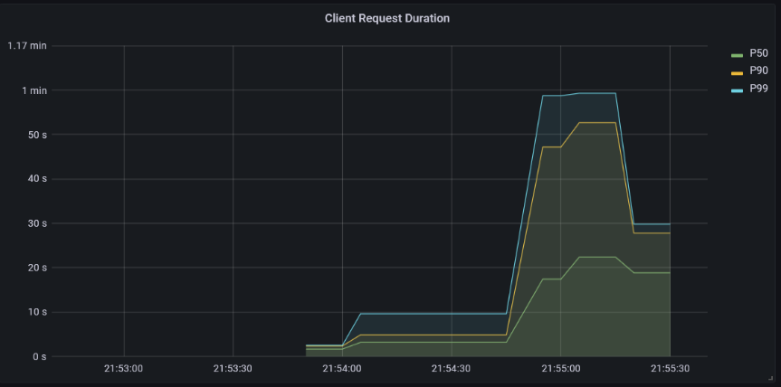**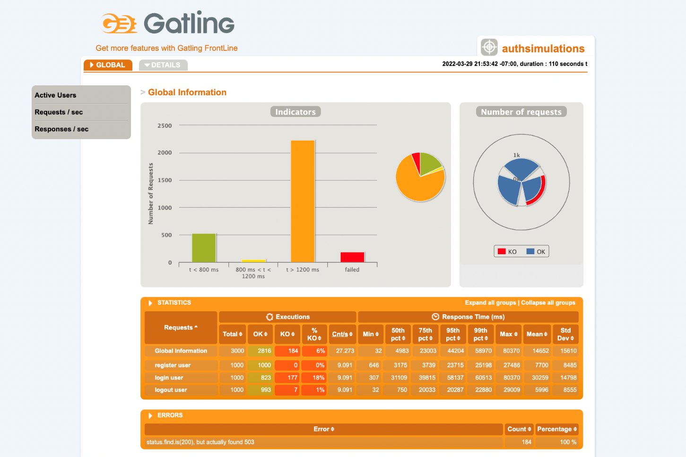Results:**

Latency (Grafana)

Gatling Report

**Learnings:**

During this test, we randomly deleted two authentication pods while the test was running. We found that while the service did not crash, it did cause request failures and increased latency. Looking at the latency plot, we can see the exact moment the pods go down due to the significant spike in latency. Furthermore, we can also see towards the end of the test that the service begins to recover. This is due to Kubernetes self healing capability. Immediately after the pods were deleted, Kubernetes immediately created two new pods to take their place. As a result, there is only a temporary increase in latency and request failures.

### Test 9

**Configuration:**

* Target Service: Authentication
* Replication Factor: (8 - Authentication, 1 - Subscription, 1 - Playlist)
* Number of Nodes: 3
* Test: A
* Failure: Request Delay

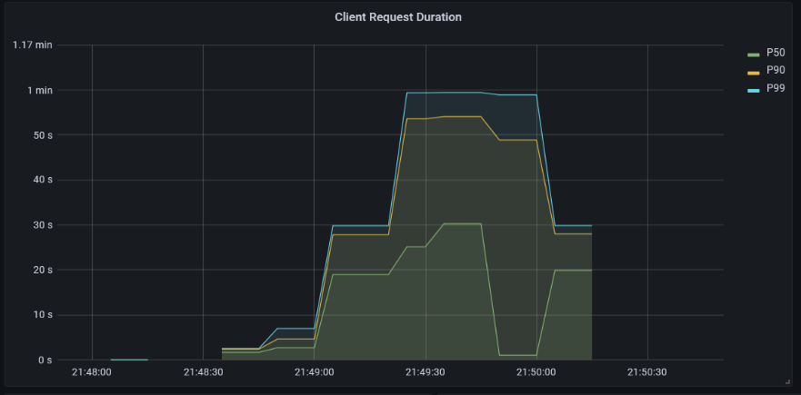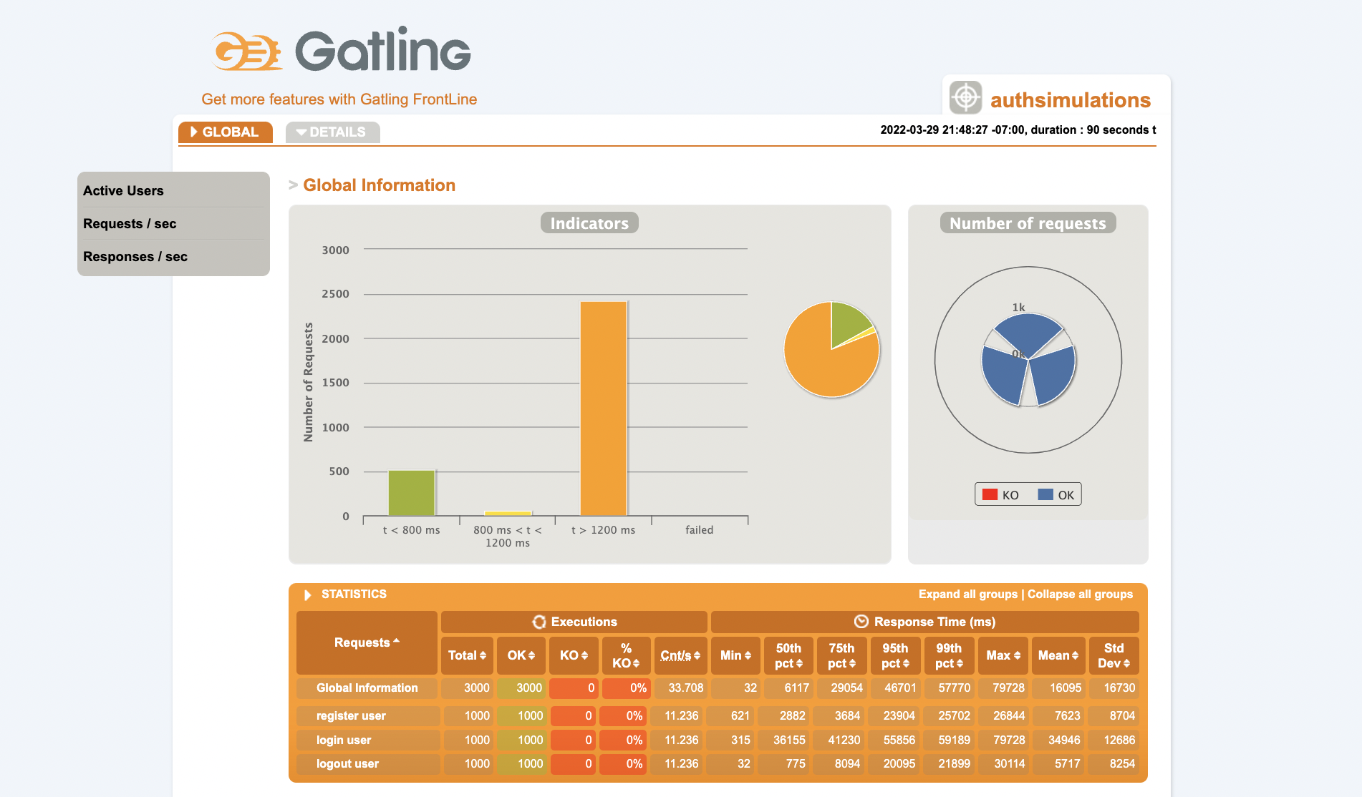**Results:**

Latency (Grafana)

Gatling Report

**Learnings:**

During this test, we configured 25 % of the requests made to the authentication service to have a delay of 25 seconds. We found to no surprise that this significantly increased the latency of the service relative to that seen in test 3. However, it did not result in any request failures. This indicates that the service using this configuration and under this load has some resistance to delayed responses.

## Failure Remedies

In this section, we explored to remedies that can be applied to failures. The goal in our case is not to improve the latency but to reduce the number of failed requests when applying test B. Due to the load of test B when applied to any service, it is not reasonable to try to meaningfully improve the latency. However, it may be possible to reduce the number of failed requests.

**Configuration:**

* Target Service: Authentication
* Replication Factor: (8 - Authentication, 1 - Subscription, 1 - Playlist)
* Number of Nodes: 3
* Test: B
* Remedy: Request Retry

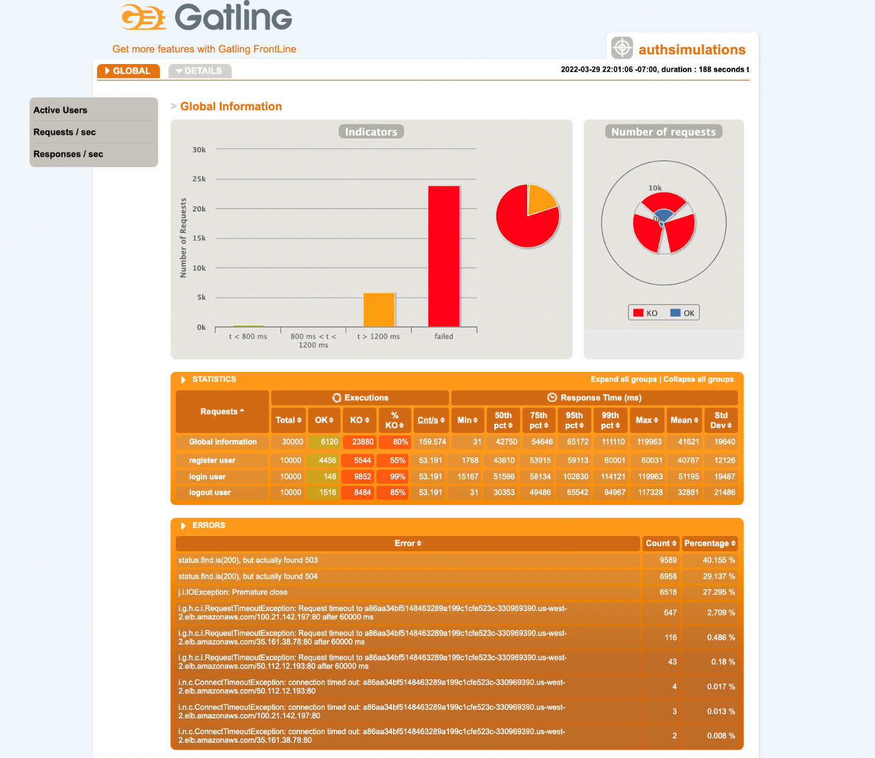**Results:**

Gatling Report

**Learnings:**

If you recall, when we applied test B on the authentication service in test 4, this resulted in a substantial number of failed requests due to the significant load of test B. To remedy this, we allow for requests to be retried 3 times with a 5 second time out between each time. However, we found that this resulted in no improvement. In fact, it slightly increased the number of failed requests by twenty. We suspect the reason for this is that when the application is under less load retrying failed requests will of course reduce the number of failures. However, this case because the application is already under such significant load, retrying the failed requests only increases the load such that they will just fail again.